 | Risk | Management | Emergency
Environmental Factors | Motor vehicle/cycleway  /pedestrian conflict around car park  - Impact injury | - Wait for educator before entering site  - Gather on grassed area next to carpark away from cars  - OR – if raining heavily move directly to Trout Centre building using paths and await educator arrival
 | Open waterways (Tongariro River, Waihukahuka Stream, pond)  - Fall in  - Drown | - Safety briefing prior to entering site OR – if raining move directly to Trout Centre building using paths and await educator arrival  - Remain on pathways unless instructed  - Do not run on site
 | Accessing waterways (Tongariro River, Waihukahuka, pond)  - Slip over  - Drown | - Safety briefing  - Recognise algae growth can be slippery  - Don’t throw stones in the river  - Check footing before shifting weight  - One student to access river at a time  - No deeper than mid-calf  - 1-1 adult-child supervision in water
 | Falling objects trees/rocks  - Impact injury | - Safety briefing  - Follow instructions of Educator  - Allow Educator to lead  - Educator to identify potential new hazards  - Avoid identified hazards/use alternative paths
 | Insects  - Bites/stings  - Anaphylaxis | - Identify relevant allergies prior to visit  - Bring appropriate medical supplies/Epipen  - First Aid kit accessible  - Refer serious cases to hospital | - Group carries first aid kit  - First Aid kits also available in Visitor Centre and Classroom
 | Slippery decks  - Falling | - Safety briefing  - No running on site  - Be aware of slippery surfaces
 | Banks / edges / slippery areas  - Falling | - Safety briefing  - Remain on paths  - No running on site  - Stay behind guide (educator)  - Do not approach open waterways unless instructed to do so
 | Low temperatures/rain  hot and sunny conditions  - Hypothermia  - Heat stress  - Sunburn | - Obtain weather report prior to visit  - Bring appropriate clothing/protective gear  - Warm clothing  - Wind protection  - Raincoat  - Sun-hat  - Sunscreen  - Water  - Check students have appropriate clothing prior to visiting site
 | Flood – Tongariro River  - Drowning | - No access to river when in flood  - Educator to assess prior to group arrival
 | Earthquake  - Impact injury | - Drop, Cover, Hold
 | Eruption  - Impact injury  - Ash inhalation | - Move to visitor centre as instructed  - Return to Turangi when safe  - Follow emergency services instructions
 | Fire  - Burns  - Smoke inhalation | - Exit in orderly fashion  - Assemble at whio aviaries | - See assembly area on attached map
Equipment | Fish-hook flying behind anglers  - Eye or delicate tissue injury | - Safety briefing prior to fishing  - Remain behind barrier chain  - Do not walk behind anglers  - Follow all instructions of anglers and educator  - Wear the provided safety glasses | - First Aid kit in Classroom  - Any fish-hook injury to be seen by a qualified doctor
 | Filleting/knife use  - Lacerations | - Parents/teachers to gut fish; or:  - With parent/teacher permission and supervision, responsible students may gut fish  - Students to stand back from table when not handling gutting equipment | - Any knife injury to be attended by a qualified doctor after initial first aid
People | Inappropriate behaviour  - Injury to self or others | - Students briefed on appropriate behaviour  - Students failing to adhere to instructions may be unable to experience the full visit
 | Lack of supervision  - Injury to self or others | - Supervisory ratio of 1 adult to 10 students to be maintained
 | Drop-off and pick-up  - Students/staff kept waiting | - Groups will be met at public carpark by educator(s)  - If it is raining heavily, move directly to the Trout Centre building following the paths; the educator will meet you there. | - If running late, or educator not present call: 027 216 4286,  - If no response, call 027 575 1397
 | Medication  - Distress | - Caregivers to ensure students have appropriate medication with them if required

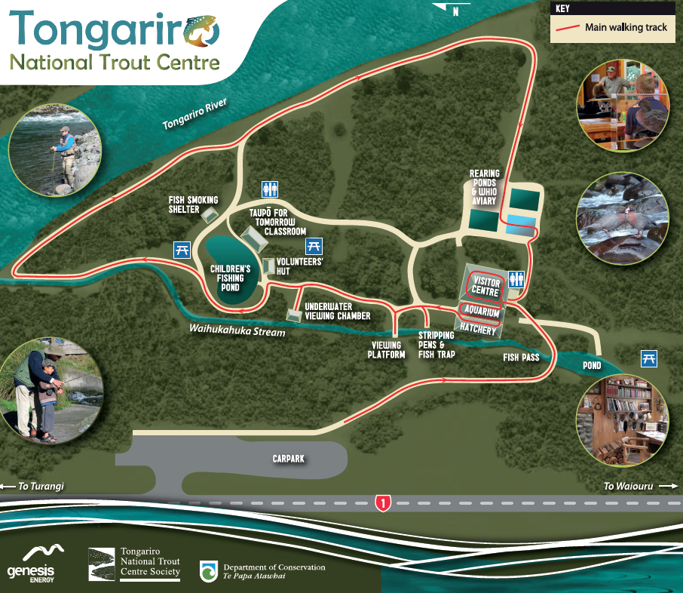
Assembly area

